Use the following StackPanel as the content of a window.

<StackPanel Background="Orange">

<Label FontWeight="Bold" FontSize="20" Foreground="White">

WPF 4.5 Unleashed

</Label>

<Label>© 2013 SAMS Publishing</Label>

<Label>Installed Chapters:</Label>

<ListBox>

<ListBoxItem>Chapter 1</ListBoxItem>

<ListBoxItem>Chapter 2</ListBoxItem>

</ListBox>

<StackPanel Orientation="Horizontal"

HorizontalAlignment="Center" TextElement.FontSize="30"

TextElement.FontStyle="Italic">

<Button MinWidth="75" Margin="10" >Help

<Button.Style>

<Style TargetType="{x:Type Button}">

<Style.Triggers>

<Trigger Property="IsMouseOver"

Value="True">

<Setter Property="Foreground"

Value="Green"/>

</Trigger>

</Style.Triggers>

</Style>

</Button.Style>

</Button>

<Button MinWidth="75" Margin="10">OK</Button>

</StackPanel>

<StatusBar>You have successfully registered this product.</StatusBar>

</StackPanel>

Your resulting window should look like this:

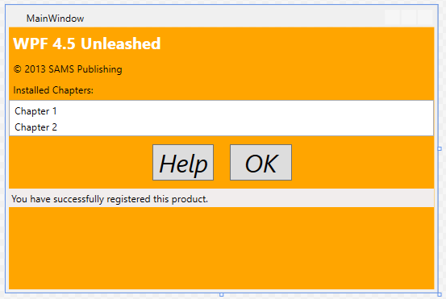

**Step 1**

Change the title bar so that in includes your name.

**Step 2**

Move all the formatting into styles in either your MainWindow resources or your Application resources.

**Step 3**

Add two buttons to the bottom of the window. Create two style sheets that can be loaded by pressing the two buttons. Use the mechanism shown in class on Monday to load the styles. For this to work, your style.xaml files must be part of your project, and you must not include styles in your window or app.

**Step 4**

Add two more buttons to the bottom that will load styles from XAML files that are NOT part of your project. The XAML files are formatted the same as in Step 3, but they are loaded with the following code:

ResourceDictionary resources = null;

using (FileStream fs = new

FileStream("skin1.xaml",

FileMode.Open,

FileAccess.Read))

{

// Get the root element:must be a ResourceDictionary

resources = (ResourceDictionary)XamlReader.Load(fs);

}

Application.Current.Resources = resources;

Using this mechanism, you CAN have a style sheet in the application, and you can also edit the XAML files while your application is running, and when you reload them you will see the changes.

**Finally**

When you are done, you should have five different appearances for your window: The default from when the program loads, and the four from the buttons. Once you click either of the second two buttons, the first two may not work. If that’s the behavior you get, that’s OK. It comes about because the styles are loaded differently and one may hide the other.

Part of your grade will be on how creatively and completely you were able to change the appearance just using styles. Simply changing colors and fonts will not give you full credit.